Ex.NO: 5 a | DATA VISUALIZATION USING MATPLOTLIB –  Sales Data
DATE:

Aim
To visualize dataset features and distributions using line charts, bar charts, pie charts, histograms, scatter plots, and box plots using Matplotlib.
Algorithm
ALGORITHM 1: LINE CHART
Objective: To visualize the monthly sales trend.
Steps
- Load the sales dataset.
- Select the Month and Sales columns.
- Plot the monthly sales using a line chart.
- Add title and axis labels.
- Display the graph.
Interpretation
The line chart shows how sales vary across different months and helps identify the sales trend.
# Program 1: Line Chart
import matplotlib.pyplot as plt
months = ["Jan","Feb","Mar","Apr","May","Jun"]
sales = [120,150,180,170,220,250]
plt.plot(months,sales)
plt.title("Monthly Sales")
plt.xlabel("Months")
plt.ylabel("Sales")
plt.show()

ALGORITHM 2: BAR CHART
Objective: To compare sales across different months.
Steps
- Select the Month and Sales columns.
- Create a bar chart using the monthly sales values.
- Add title and axis labels.
- Display the chart.
Interpretation
The bar chart helps compare the sales values across different months.
# Program 2: Bar Chart
plt.bar(months,sales)
plt.title("Monthly Sales")
plt.xlabel("Months")
plt.ylabel("Sales")
plt.show()

ALGORITHM 3: PIE CHART
Objective: To visualize the distribution of sales across different months.
Steps
- Select the sales values.
- Create a pie chart using the sales values.
- Display percentage labels.
- Add a suitable title.
- Display the chart.
Interpretation
The pie chart shows the percentage contribution of each month to the total sales.
# Program 3: Pie Chart
departments = ["HR","IT","Finance","Sales"]
employees = [25,40,20,15]
plt.pie(employees,
labels=departments,
autopct='%1.1f%%')
plt.show()

ALGORITHM 4: BOX PLOT
Objective: To visualize the distribution of monthly sales.
Steps
- Select the Sales column.
- Create a box plot.
- Add a suitable title and axis label.
- Display the plot.
Interpretation
The box plot shows the distribution of sales values and helps identify possible outliers.
# Program 6: Box Plot
salary=[25000,27000,30000,
32000,35000,
40000,150000]
plt.boxplot(salary)
plt.show()

ALGORITHM 7: MULTIPLE LINE CHARTS
Objective: To compare sales and profit across different months.
Steps
- Store the profit values.
- Plot the sales values using a line chart.
- Plot the profit values using another line chart.
- Add title, axis labels and legend.
- Display the graph.

Interpretation
The multiple line chart compares the sales and profit values across different months.
# Program 7: Multiple Line Charts
months=["Jan","Feb","Mar","Apr"]
sales=[120,150,180,200]
profit=[20,30,40,50]
plt.plot(months,sales,label="Sales")
plt.plot(months,profit,label="Profit")
plt.legend()
plt.show()

Output :

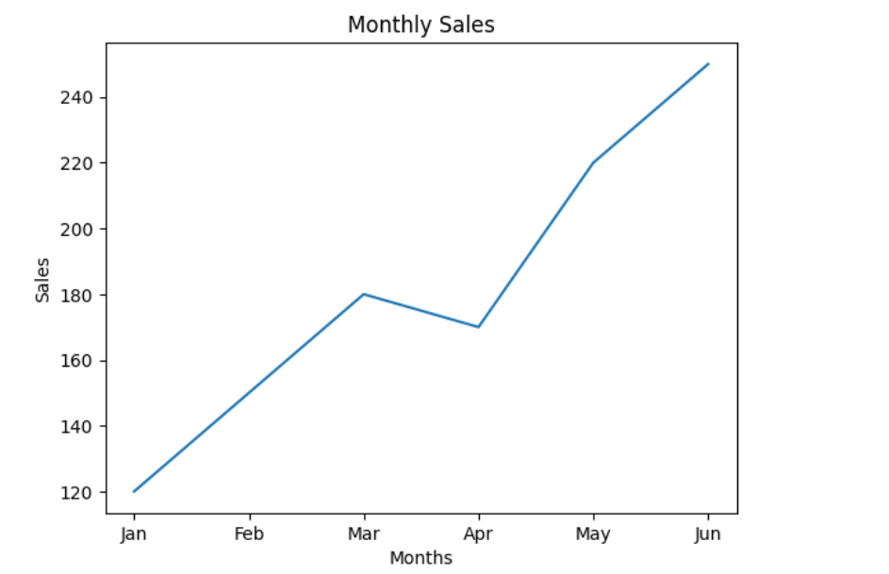

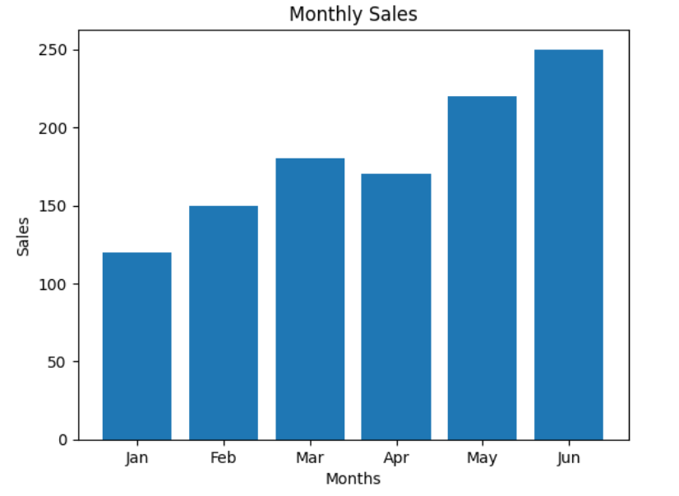

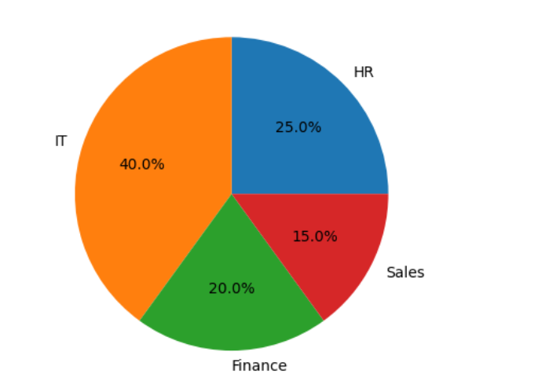
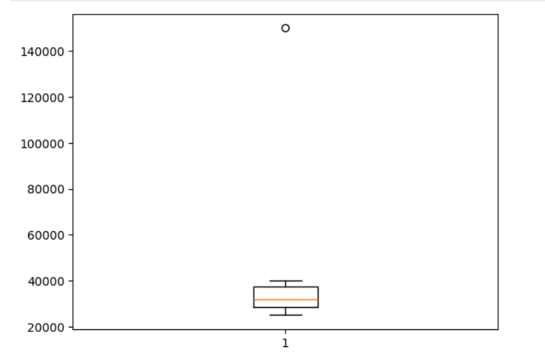

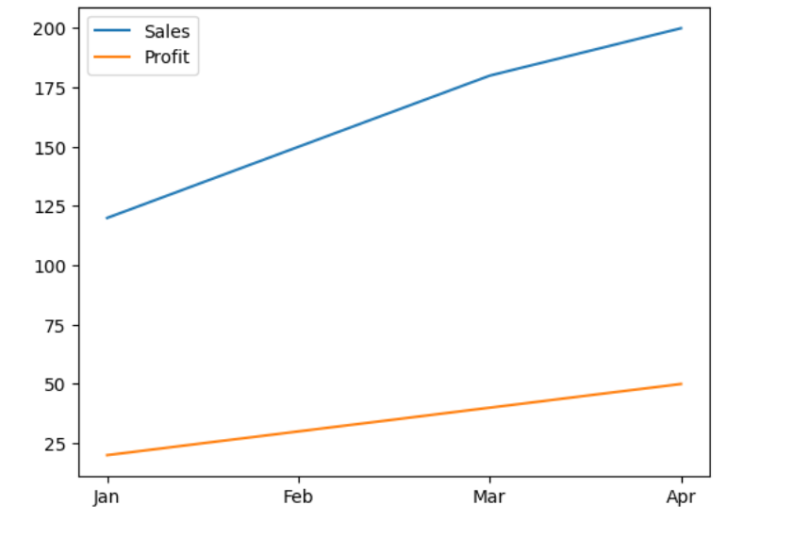

Result
Thus, various visualization techniques such as Line Charts, Bar Charts, Pie Charts, and Box Plots were successfully created using Matplotlib.

